**Class Diagram**

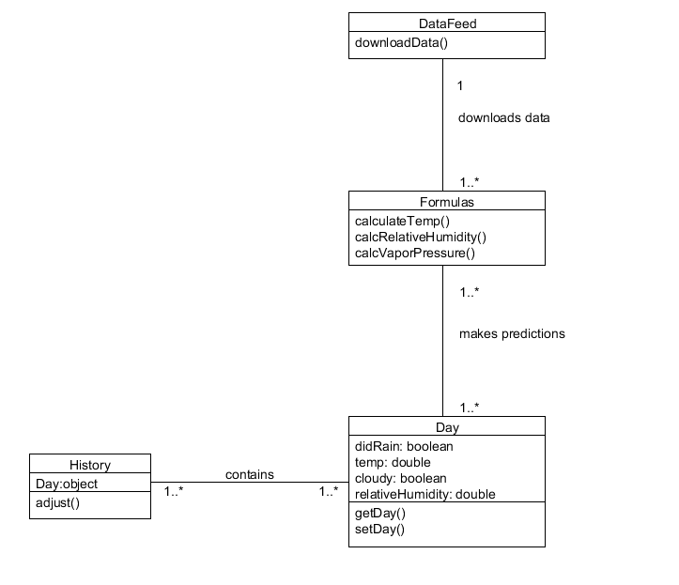

**Sequence Diagram**

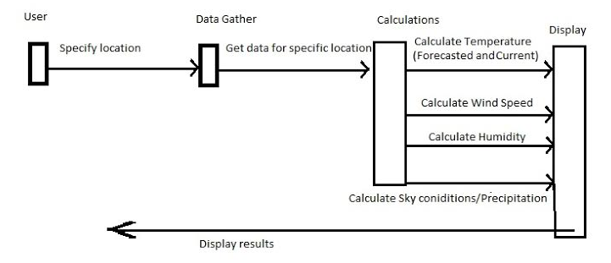

**Activity Diagram**

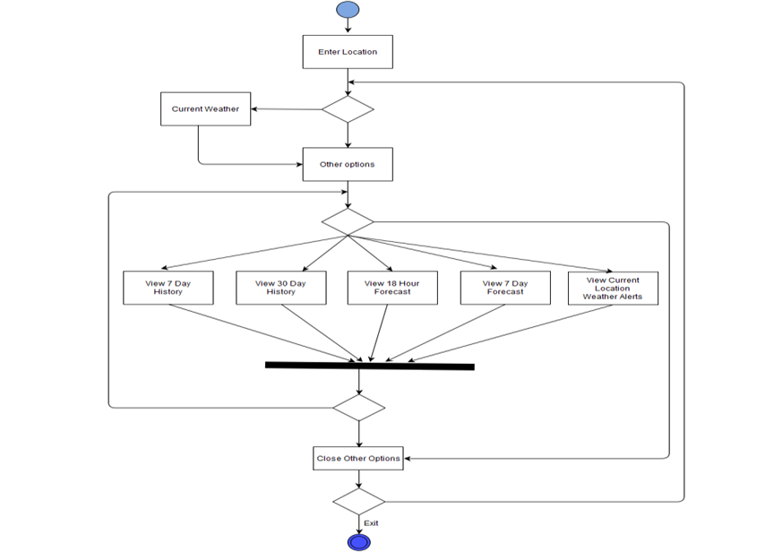

Submitted by:

Dilusha Harischandra

Efren Ulloa

Emmanuel Raguay

Lalitha Vedula

Rob Niesen